TypeScript – Types

Example:
let age:number=20;

If we type let age again it will show the following error
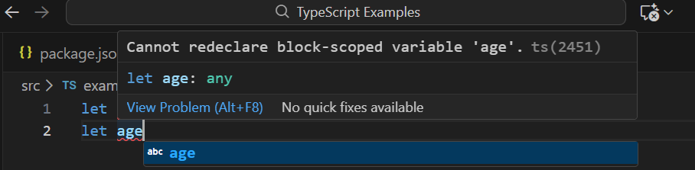

If we try to assign string value to age, it will show the following error
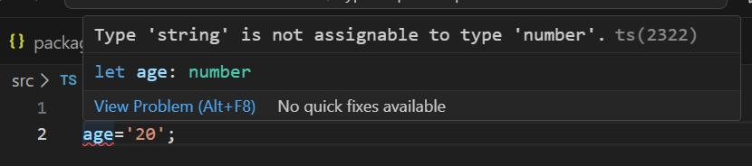

If we wanted to utilize the facility of JavaScript, we can use the following:
let age:any=20;
age='20';
--------------------------------------------------------------------------------------------------------------------------
Basic data types
- Primitive
- Reference
Primitive Data Types
- number, string, boolean
- Primitive data types represent single, immutable values.
Example Behavior:
let a = 10;
let b = a; // b is a copy of the value of a
a = 20; // Changes a, but b remains 10
console.log(b); // Output: 10
Reference Data Types
- Array
- Object
- Functions
- Classes
- interfaces
Reference data types (objects) are dynamic in size.
The variable itself does not hold the object, but rather a pointer or reference to the object's location in the heap.
- Mutable: The properties of a reference type can be altered.
- Stored by reference: When you copy a reference variable, you are copying the pointer, not the actual object. Both variables then point to the same location in memory.
Example Behavior:
let obj1 = { name: "John" };
let obj2 = obj1; // obj2 stores a reference to the same object as obj1
obj1.name = "Jane"; // Modifies the *single* object in memory
console.log(obj2.name); // Output: Jane
-------------------------------------------------------------------------------------------------------------------------

Example for types

//Primitive data types
let age: number = 20;
let name: string = "Praba";
let isMajor: boolean = true;

console.log(typeof(age));
console.log(typeof(name));
console.log(typeof(isMajor));

// Reference type - Arrays
let student:string []=["Praba","SRK"];
console.log(student);

// Reference type - union datatypes
let student1:(string|number) []=[1,"SRK"];
console.log(student1);

// Reference type - Object
let student2:{sno:number;name:string}={
sno:1,
name:"welcome"
}
console.log(student2);

//Reference type - Array of objects
let employee:{sno:number;name:string}[]=[
{sno:1, name:"Praba"},
{sno:2, name:"SRK"},
{sno:3, name:"Raji"}
];
console.log(employee);

// create type of our own.
type Employee={sno:number;name:string};

// usage of customized data type
let employee1:Employee[]=[
{sno:1, name:"ABC"},
{sno:2, name:"XYZ"}
];
console.log(employee1);

// Type info. kept in separate file 'custome_types.ts
import { type Emp } from "./types/employee.type";
let employee2:Emp[]=[
{sno:1, name:"BP"},
{sno:2, name:"MS"}
];
console.log(employee2);

import { type Student } from "./types/employee.type";
let CSE_A:Student[]=[
{sno:1,name:null,age:undefined},
{sno:2,name:"SRK",age:20},
{sno:3,name:"Praba",age:undefined},
];

console.log(CSE_A);

